Report Details
Site Number: | NA | Scan Date: | 5 Jun 2025
Site Name: | Ottawa Heart | Report Date: | 10 Jun 2025
PI Name: | Dr. Marino Labinaz | Created By: | Mikhail Mikhelson
Comments: | NA

Patient Details
Patient Number: | CAN-1105-017 | Height: NA |  | NYHA: NA
Gender: | NA | Weight: NA |  | EuroScore II: NA
Age: | NA | BMI: NA
Comments: | NA

Anatomical Measurements Results
Axial Plane  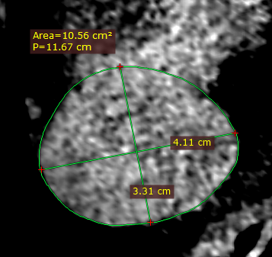  Length: 4.11cm  Length: 3.31cm  Perimeter: 11.67cm  Diameter: 3.71cm  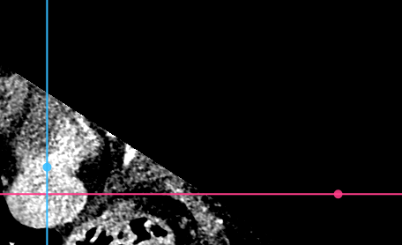 | Sagittal Plane  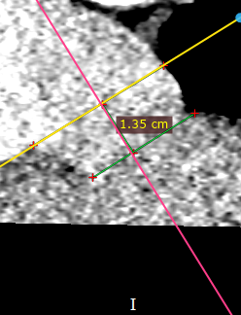 | Coronal Plane  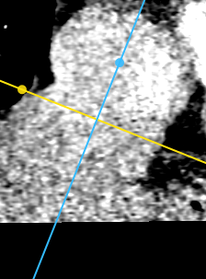  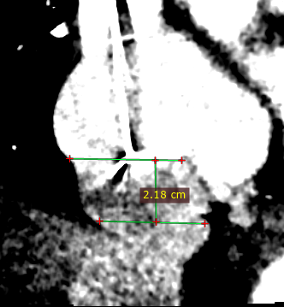  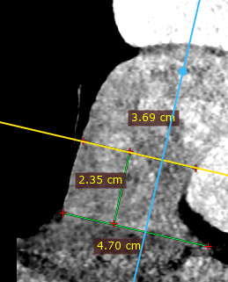
  - IVC Diameter Measurements
    - At the RA-IVC junction – Measured in Axial Plane
    - IVC Diameter 1.35cm Below the RA-IVC junction – Measured in Axial Plane
Axial Plane  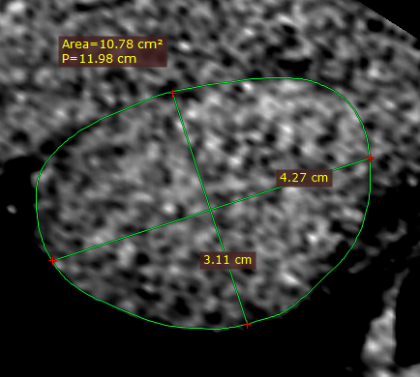  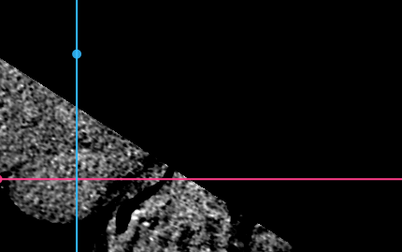  Length: 4.27сm  Length: 3,11cm  Perimeter: 11.98cm  Diameter: 3.81cm | Sagittal Plane  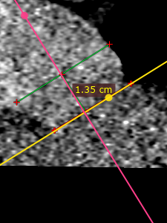 | Coronal Plane  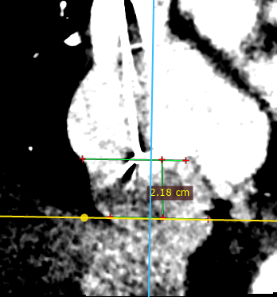  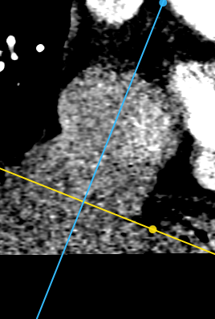

  - SVC Diameter Measurements
    - At the RA-SVC junction – Measured in Axial Plane
Axial Plane  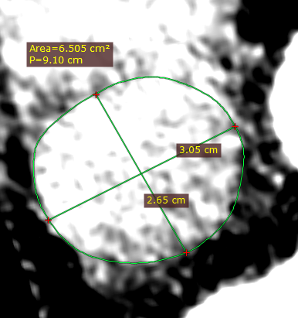  Length: 3.05cm  Length: 2.65cm  Perimeter: 9.1cm  Diameter: 2.9cm  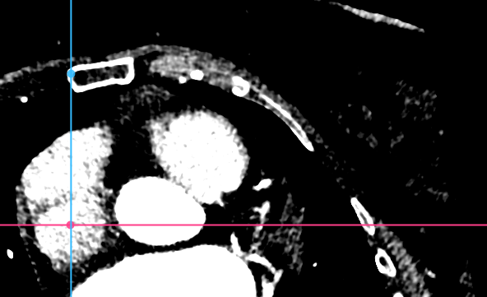 | Sagittal Plane  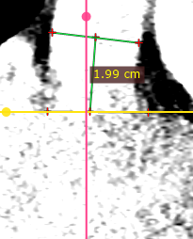 | Coronal Plane  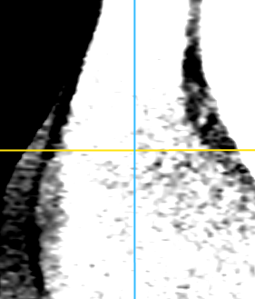

    - SVC Diameter 2cm Above the RA-SVC junction – Measured in Axial Plane
Axial Plane  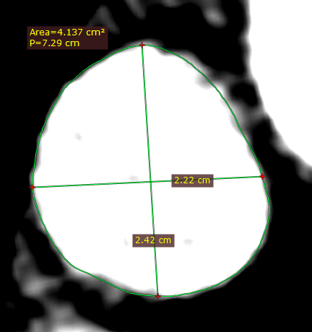  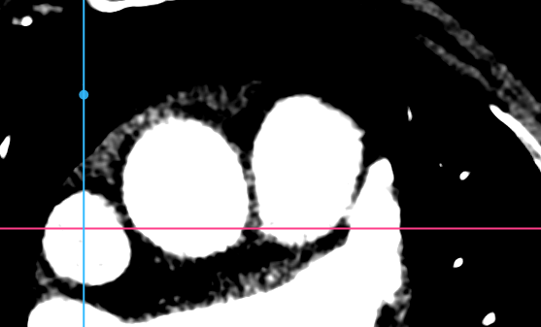  Length: 2.22cm  Perimeter: 7.29cm  Diameter: 2.32cm  Length: 2.42cm | Sagittal Plane  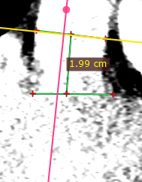 | Coronal Plane  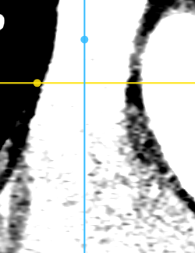  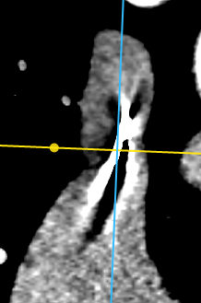  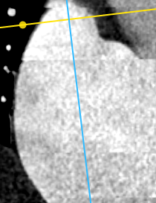

    - SVC Diameter at the Azygos level – Measured in Axial Plane
Axial Plane  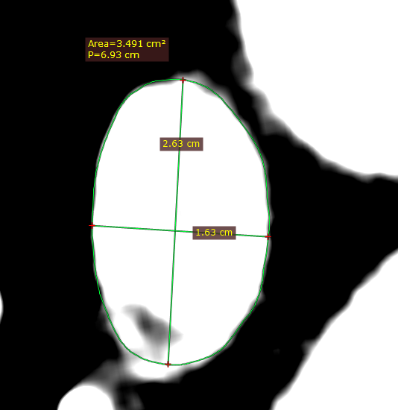  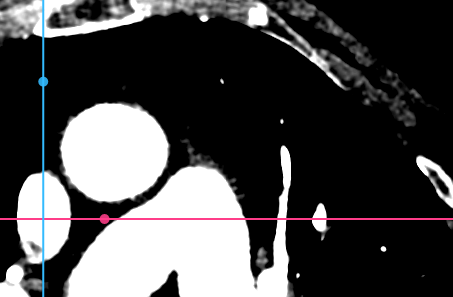  Length: 2.63cm  Length: 1.63cm  Perimeter: 6.93cm  Diameter: 2.21cm | Sagittal Plane  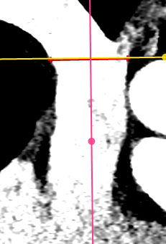 | Coronal Plane  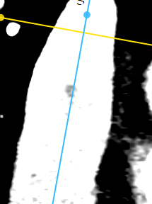

    - SVC Diameter at Innominate level – Measured in Axial Plane
Axial Plane  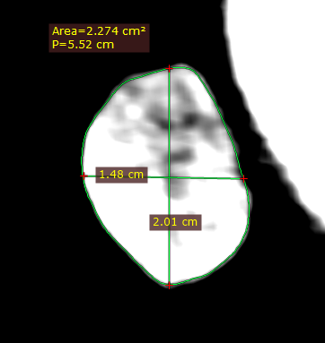  Length: 1.48cm  Perimeter: 5.52cm  Diameter: 1.76cm  Length: 2.01cm  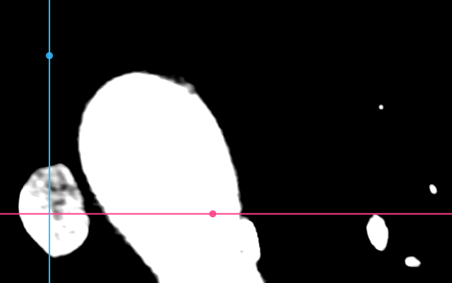 | Sagittal Plane  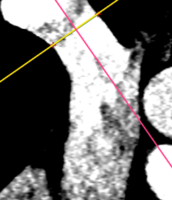 | Coronal Plane  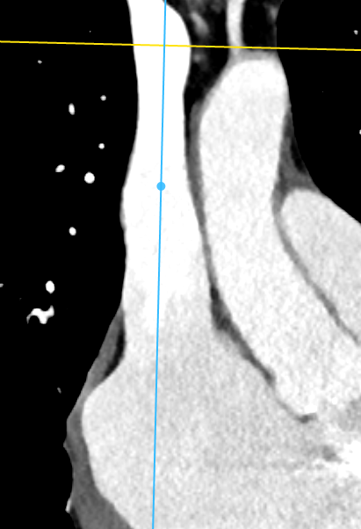  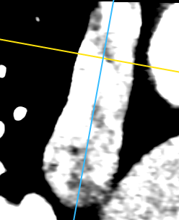

  - Hepatic Vein Distance From IVC-RA Junction Measurement
    - Hepatic Vein Distance - Measured in Sagittal Plane
Axial Plane  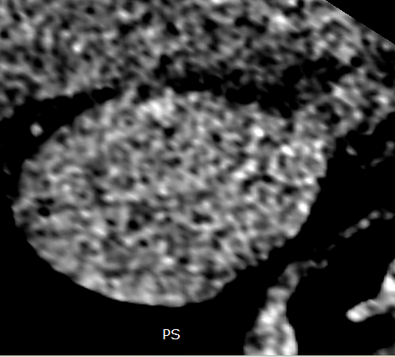 | Sagittal Plane  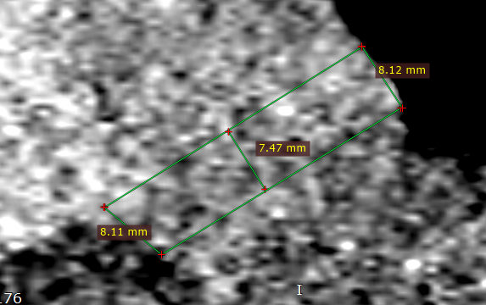  Length: 7.47mm | Coronal Plane  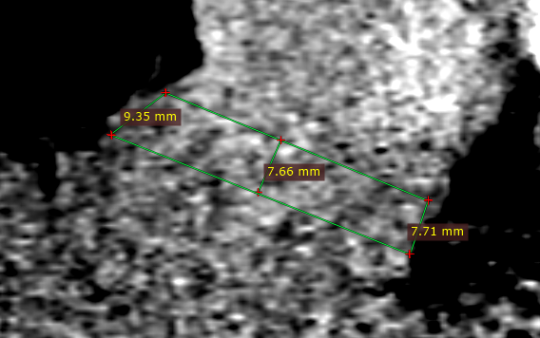

    - Hepatic Vein Distance - Measured in Coronal Plane
Axial Plane   | Sagittal Plane   | Coronal Plane    Length: 7.66mm

  - RA Span and Width Measurements
    - Measured in Sagittal Plane:
Axial Plane  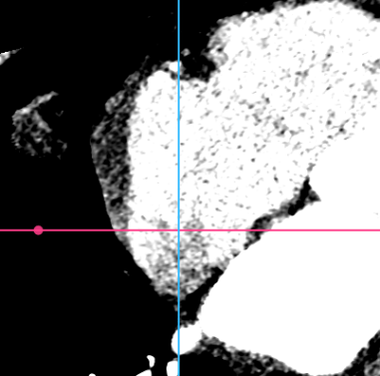 | Sagittal Plane  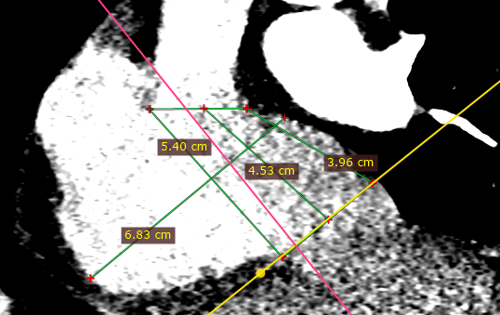  Length: 5.40cm  Length: 3.96cm  Length: 4.53cm  Length: 6.83cm | Coronal Plane  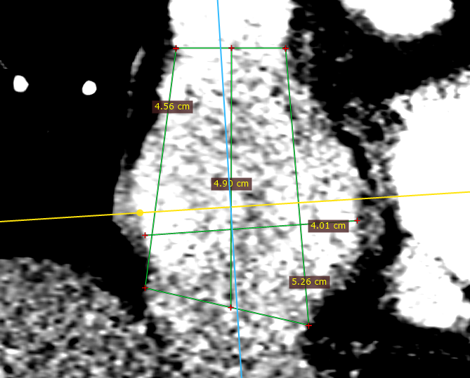

    - Measured in Coronal Plane:
Axial Plane   | Sagittal Plane   | Coronal Plane    Length: 5.26cm  Length: 4.56cm  Length: 4.01cm  Length: 4.90cm

  - Distance of First Bifurcation from SVC-RA Inlet – Measured in Sagittal Plane
Axial Plane  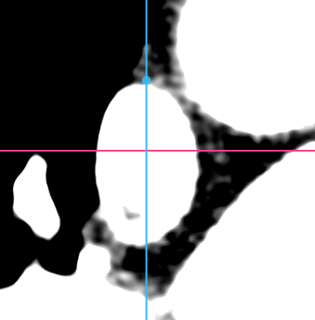 | Sagittal Plane  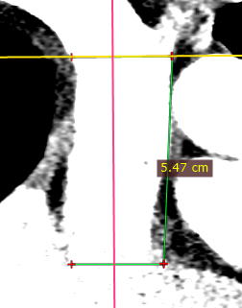  Length: 5.47cm | Coronal Plane  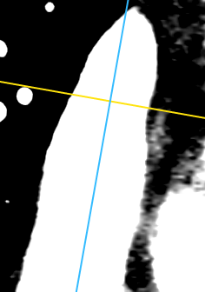
Parameter | Result [mm]
Innominate to skirt position | 122.0
Azygos to skirt position | 100.8
Hepatic vein to RA distance (Coronal) | 7.47
IVC diameter at IVC-RA junction | 37.1
IVC diameter 1.35cm below IVC-RA junction | 38.1
SVC diameter at SVC-RA junction | 29.0
SVC diameter 2cm above the SVC-RA junction | 23.2
SVC diameter at the Azygos level | 22.1
SVC diameter at the Innominate level | 17.6
SVC diameter at 90 mm from device skirt level | 18.0
SVC diameter at 115 mm from device skirt level | 23.5
RA length (Sagittal) | 54.0
RA width (Sagittal) | 68.3
RA length (Coronal) | 52.6
RA width (Coronal) | 40.1
Azygos to RA distance | 54.7

Measurements Results – Summary
Prepared By: | Position | Company | Date | Signature
Mikhail Mikhelson | Clinical Research Associate | Innoventric Ltd. | 11 June 2025
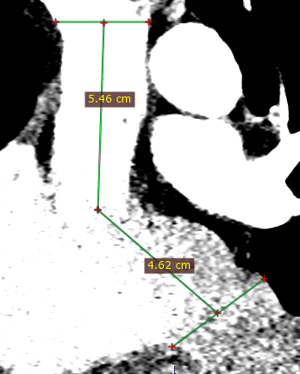
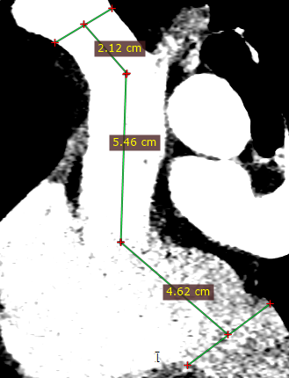
Length: 10.08cm (total)
Length: 12.20 cm (total)

